Draw that Landform
Example:
Mountain Landscape
Mountain landscapes are formed by tectonic plates on the Earth’s surface pushing against each other. This movement and pressure causes the shape of the land to change. Mountains rise high above their surroundings.
Landforms included:
mountain | ridge | valley
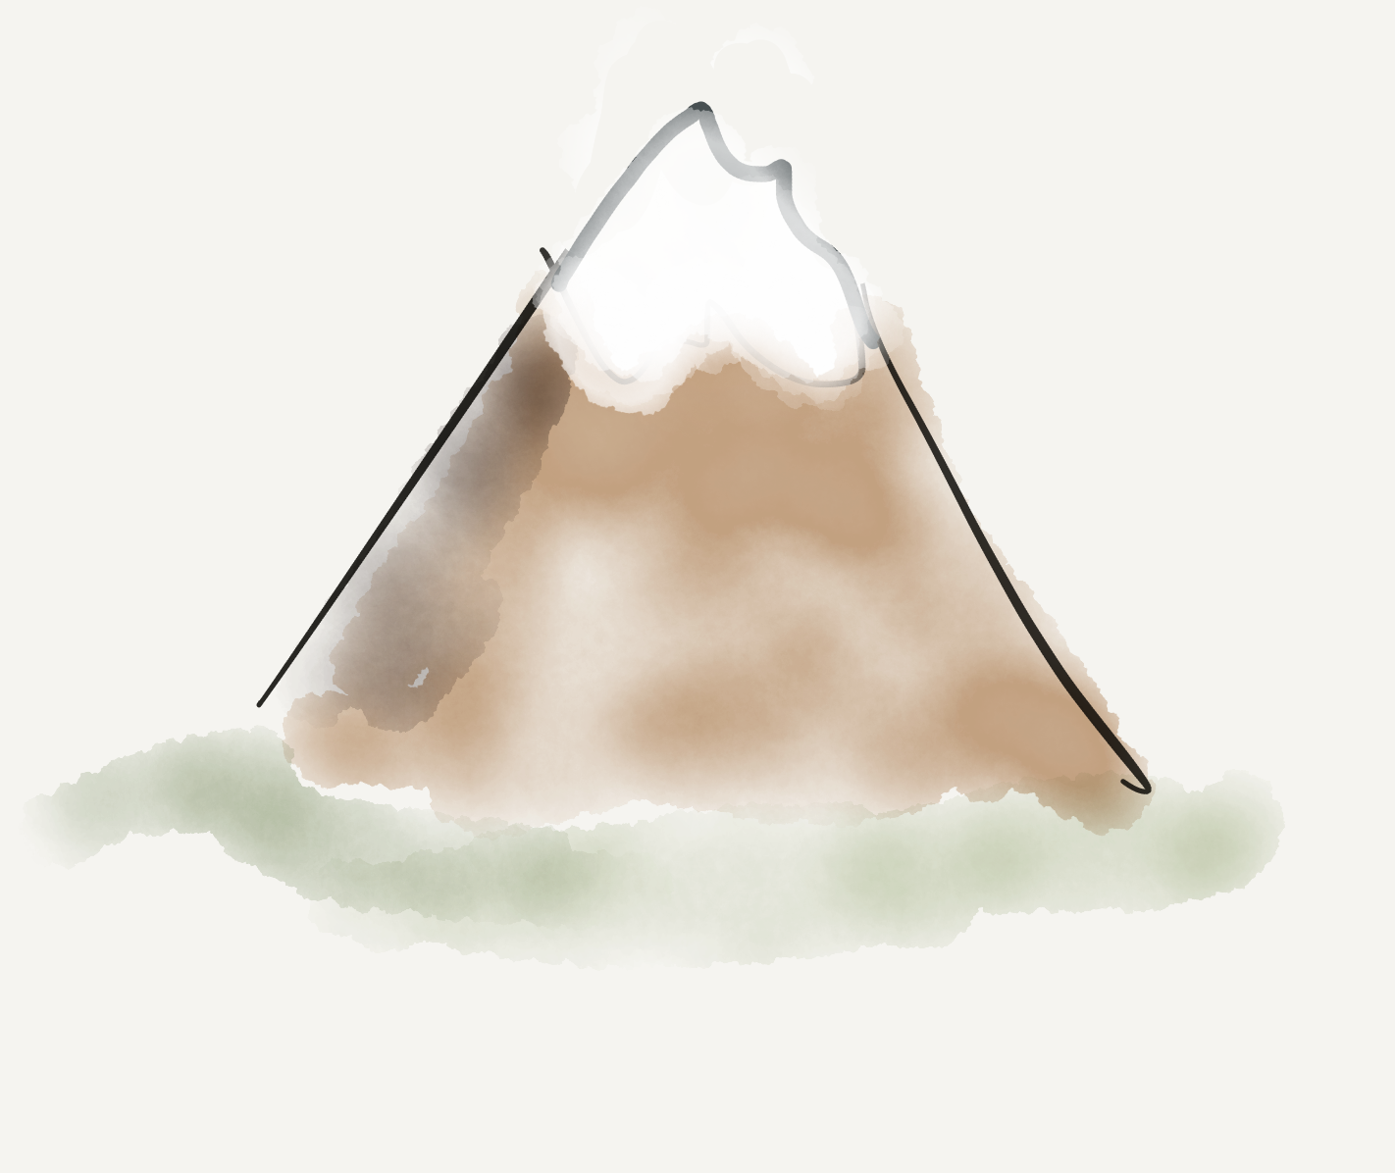 | 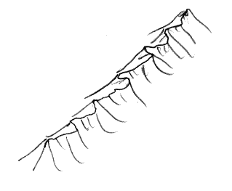 | 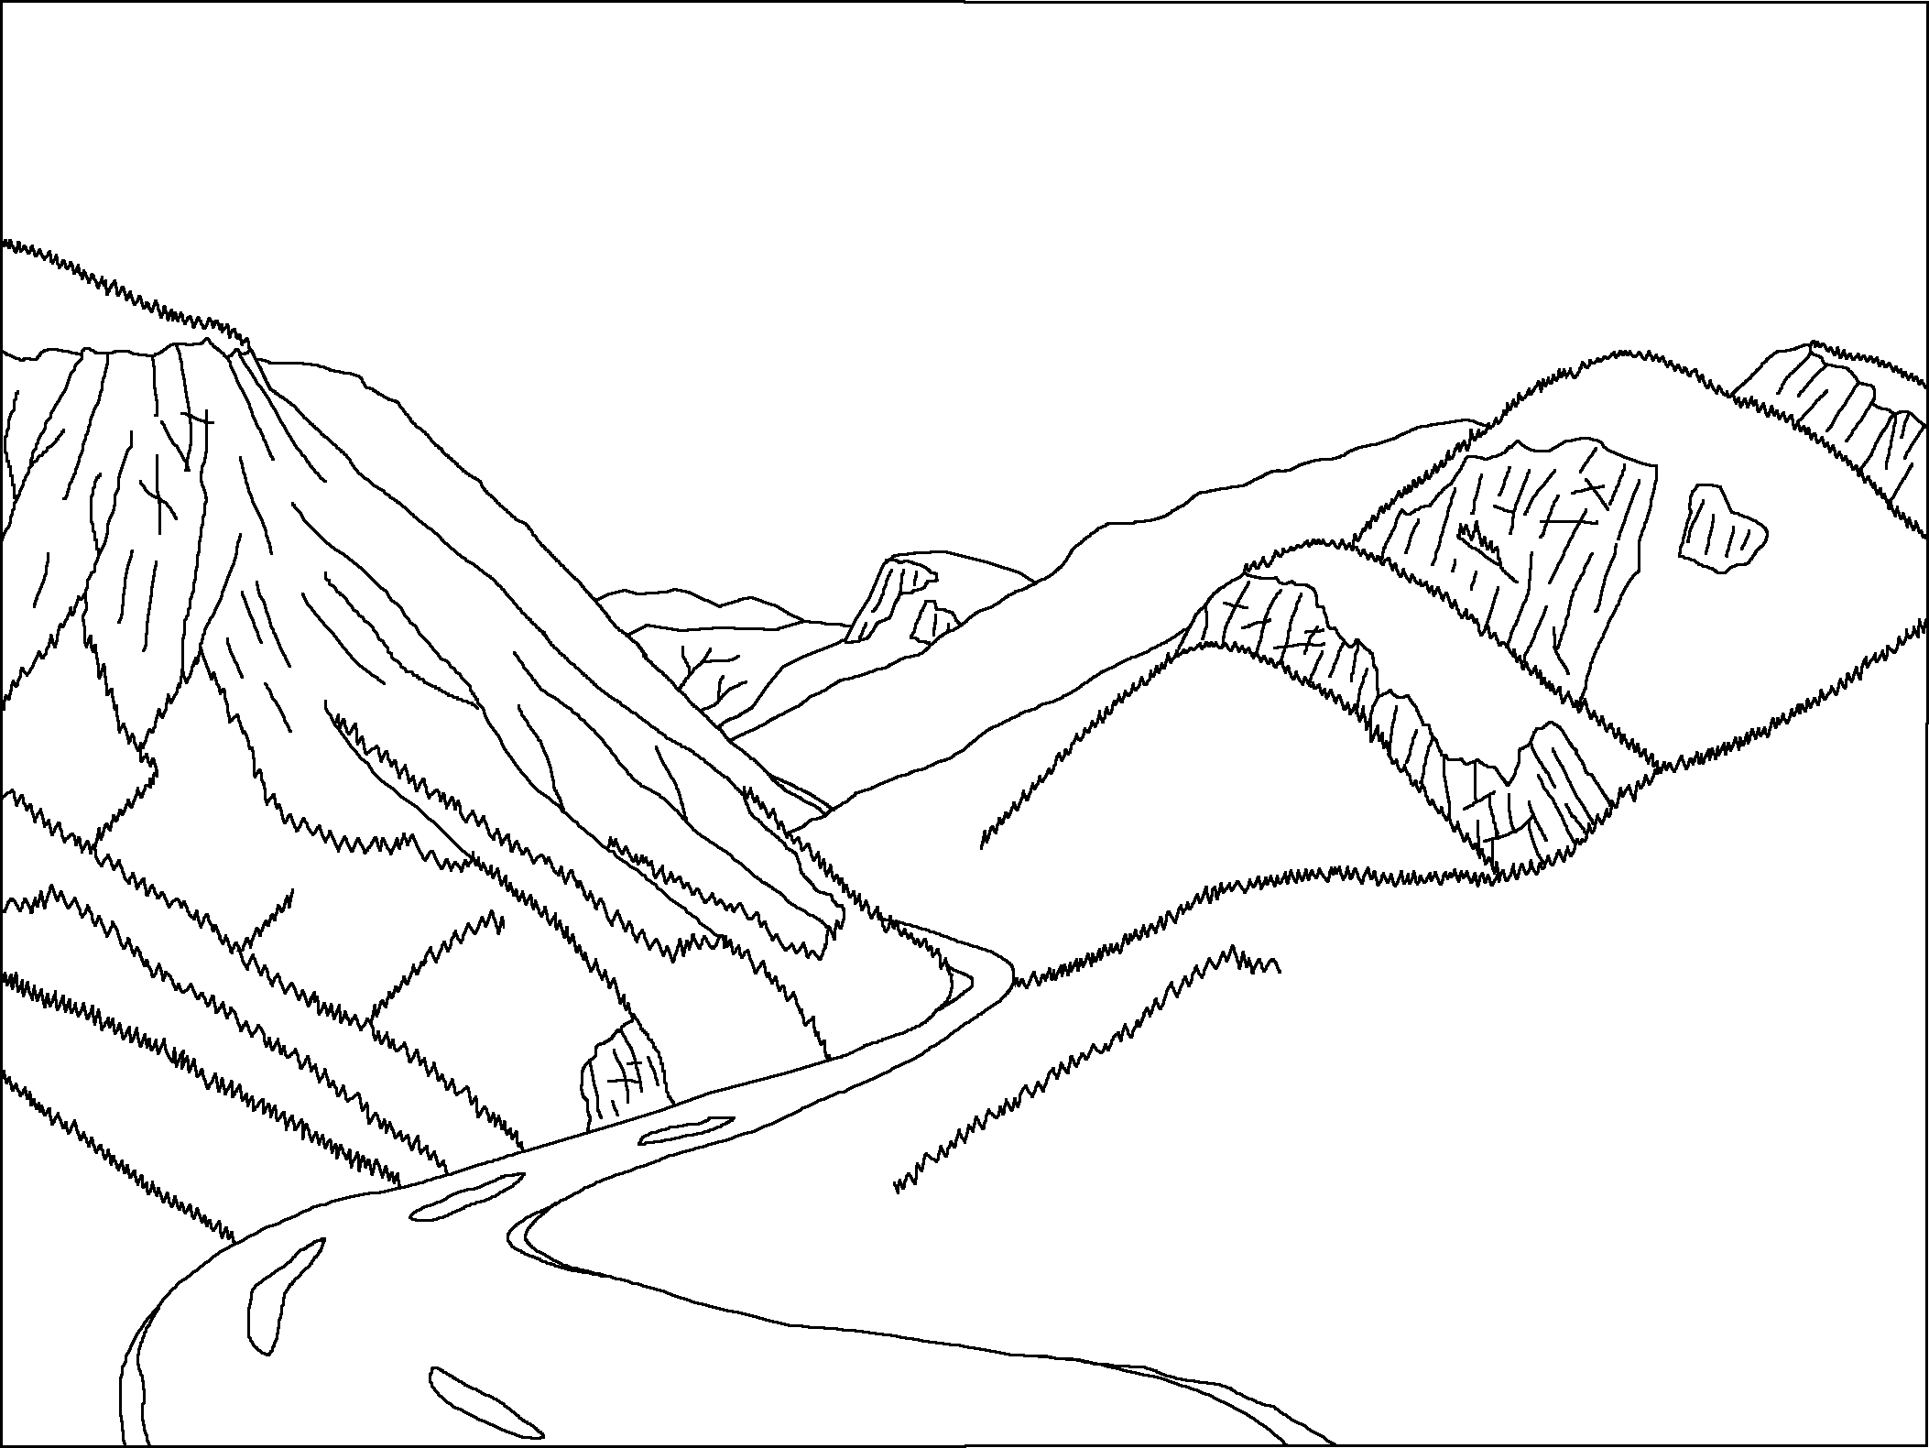

Coastal Landscape
Landforms included:
Stack | Beach | Headland

Riverine Landscape
Landforms included:
Flood plain | River Bed | Billabong

Desert Landscape
Landforms included:
Inselberg | Oasis | Grassland Plains

Karst Landscape
Landforms included:
Spring | Cave | Stalactite

